Dataset 10: Mindfulness & Attention (Before–After)

Scenario Overview
Participants completed a brief mindfulness exercise. Attention scores (out of 30) were recorded immediately before and after the session for each participant.

Data Summary
Participant | Before | After
P1 | 18 | 20
P2 | 20 | 21
P3 | 16 | 18
P4 | 22 | 22
P5 | 19 | 20
P6 | 21 | 23
P7 | 17 | 16
P8 | 23 | 24
P9 | 15 | 17
P10 | 20 | 21

Figure
Figure 1. Attention scores before and after a mindfulness exercise.
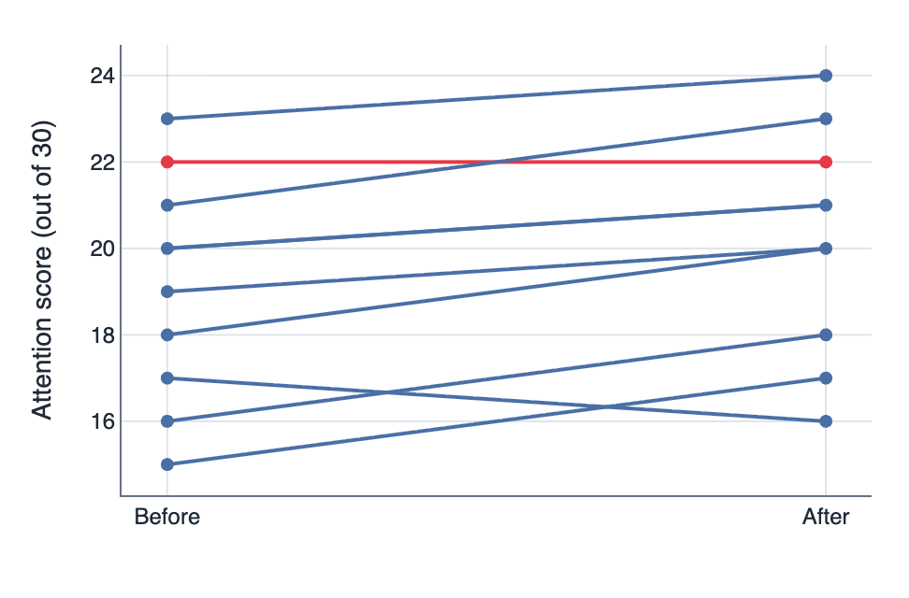

IA1 Practice Questions
- Calculate: Calculate the mean change in attention score.

- Determine: Determine which participant improved the least.

- Compare: Compare the overall before versus after pattern.

- Identify: Identify any non-responders.

- Draw: Draw a conclusion about the association between a short mindfulness intervention and attention scores.

- Justify: Justify one limitation of this dataset.

